MIRANDA V. ARIZONA (1966)

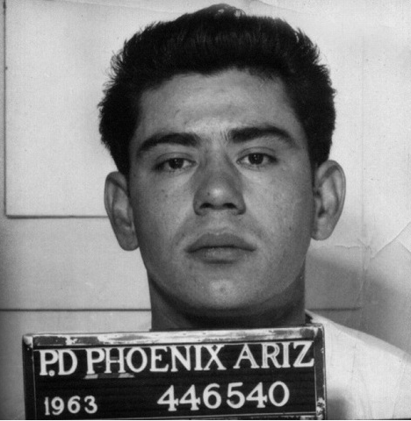
Background of the Case

Ernesto Miranda was a poor Mexican immigrant living in Phoenix, Arizona in 1963. A Phoenix woman who was kidnapped and raped identified Miranda in a police lineup. Miranda was arrested, charged with the crimes, and questioned by the police for two hours. The police officers questioning him did not inform him of his Fifth Amendment right against self-incrimination or of his Sixth Amendment right to the assistance of an attorney. The Fifth Amendment states that no person “shall be compelled in any criminal case to be a witness against himself…” The Sixth Amendment states that, “In all criminal prosecutions, the accused shall enjoy the right…to have the assistance of counsel for his defense.”

As a result of the questioning, Miranda confessed to the crimes in writing. His statement also said that he was aware of his right against self-incrimination. During his trial, the prosecution used his confession to obtain a conviction, and Miranda was sentenced to 20-30 years in prison on each count.

Miranda appealed his case to the Arizona Supreme Court. His attorney argued that his confession should have been excluded from trial because he had not been informed of his rights, nor had an attorney been present during his interrogation. The police officers involved admitted that they had not given Miranda any explanation of his rights. The state argued, however, that because Miranda had been convicted of a crime in the past, he must have been aware of his rights. The Arizona Supreme Court denied Miranda’s appeal and upheld his conviction.

The case comes down to this fundamental question: What is the role of the police in protecting the rights of the accused, as guaranteed by the Fifth and Sixth Amendments to the Constitution? The Supreme Court of the United States had made previous attempts to deal with these issues. The Court had already ruled that the Fifth Amendment protected individuals from being forced to confess. They had also held that persons accused of serious crimes have a fundamental right to an attorney, even if they could not afford one. In 1964, after Miranda’s arrest, but before the Court heard his case, the Court ruled that when an accused person is denied the right to consult with his attorney, his or her Sixth Amendment right to the assistance of a lawyer is violated. But do the police have an obligation to ensure that the accused person is aware of these rights before they question that person?

In 1965, the Supreme Court of the United States agreed to hear Miranda’s case. At the same time, the Court agreed to hear three similar cases. The Court combined all the cases into one case. Since Miranda was listed first among the four cases considered by the court, the decision came to be known by that name. The decision in Miranda v. Arizona was handed down in 1966.

Decision of the Court

In a 5-4 decision, the Supreme Court ruled in favor of Miranda. The majority opinion, written by Chief Justice Earl Warren, concluded that defendants arrested under state law must be informed of their constitutional rights against self-incrimination and to representation by an attorney before being interrogated when in police custody. Justices Clark, Harlan, Stewart, and White dissented.

In their majority opinion, the justices explained that the Fifth Amendment right against self-incrimination is fundamental to our system of justice and is “one of our Nation’s most cherished principles.” This guarantee requires that only statements freely made by a defendant may be used in court. The justices described some of the techniques used by police officers in interrogations. They observed that “the modern practice of in-custody interrogation is psychologically rather than physically oriented,” and cited the advantage police officers hold in custodial interrogations (interrogations that take place while the subject is in police custody). Because of these advantages, they concluded that “the very fact of custodial interrogation exacts a heavy toll on individual liberty, and trades on the weakness of individuals.”

The Court ruled that in order to reconcile the necessary practice of custodial interrogations with the guarantees of the Fifth Amendment, police must ensure that defendants are aware of their rights before they are interrogated in custody. Because the right against self-incrimination is so important to our system of justice, a case by case determination made by police officers of whether each defendant understands his or her rights is not sufficient. Before interrogating defendants in police custody, they must be warned 1) that they have the right to remain silent, 2) that anything they say may be used against them in court, 3) that they have the right to an attorney, either retained by them or appointed by the court, and 4) that if they waive these rights, they retain the right to ask for an attorney at any time during the interrogation, at which point the interrogation can only continue in the presence of a lawyer.

The Supreme Court reasoned that because the right against self-incrimination is so fundamental, and because it is so simple to inform defendants of their rights, any statements made by defendants during a custodial interrogation in which the defendant has not been read these “Miranda rights” are inadmissible in both state and federal courts.

Justice Harlan wrote the main dissent. He argued that the newly created rules did not protect against police brutality, coercion or other abuses of authority during custodial interrogations because officers willing to use such illegal tactics and deny their use in court were “equally able and destined to lie as skillfully about warnings and waivers.” Instead, he predicted that the new requirements would impair and substantially frustrate police officers in the use of techniques that had long been considered appropriate and even necessary, thus reducing the number of confessions police would be able to obtain. He concluded that the harmful effects of crime on society were “too great to call the new rules anything but a hazardous experimentation.”

QUESTIONS FOR DISCUSSION AND ANALYSIS

- What rights of the accused does the Fifth Amendment protect? The Sixth Amendment?

- If the police had informed Ernesto Miranda of these rights, do you think he might have done anything differently? Explain your answer.

- What was the Court’s decision?

- What was Justice Harlan’s dissent?

- Individual rights must be balanced against the values of society at large. For instance, the right to free speech must be balanced against our desire for an orderly society. This is why demonstrations, while protected by the First Amendment, can have certain restrictions placed on them. In Miranda v. Arizona, what values or goals of society must be balanced against the right against self-incrimination and the right to counsel? Why?

